**Project Title: Supply Chain Management User**

**Authentication System**

**Developed by**

**Roll No: 22881A05N4, 22881A05K7**

**Name: Uday Kiran, A. Raj Kumar**

**Class: II B.Tech. CSE-D**

**Regulation: R22**

**Under the Guidance of**

**Dr. Vasantha SV, Associate Professor, CSE Dept.**

**Github Link:** [**https://github.com/achiever2004/ads-project**](https://github.com/achiever2004/ads-project)

**Abstract**

This project involves developing a user authentication and management system for a supply chain management application. The system comprises a registration (signup) process, a login mechanism, and a role-based dashboard display. The project utilizes the XAMPP control panel to manage Apache and MySQL software packages, enabling the hosting of the web application on a local server.

**Problem Statement**

The goal of this project is to create a secure and efficient registration and login system for a supply chain management system. The system should:

1. Allow users to register with their personal information and position within the supply chain.
2. Encrypt user passwords and data before storing them in the database.
3. Decrypt passwords and data during login to authenticate users.
4. Display different dashboards based on the user's position.
5. To Use local server hosting for development and testing.

**Explanation of Logic**

**Registration**

1. Users fill out a registration form with their details.
2. The passwords and data is encrypted.
3. Encrypted passwords and data and other user details are stored in a MySQL database.

**Login**

1. Users enter their username and password in the login form.
2. The system retrieves the encrypted password from the database.
3. The stored password is decrypted.
4. If the decrypted password matches the entered password, the user is authenticated.
5. Based on the user's position, the corresponding dashboard is displayed.

**Key Features**

1. User Registration: Secure storage of user details with encryption of data while storing and retrieving.
2. User Login: Decryption of passwords for authentication.
3. Role-Based Dashboard: Different UI for different user roles (manager, employee, supplier).
4. Data Security: We are not stored the data of a user into the database directly, rather we encrypted the data before storing into the database and we decrypted the user data while retrieving from database.
5. Local Hosting with XAMPP: Development and testing on a local server environment.

**Implementation Process**

**Prerequisites**

1. XAMPP: Installed XAMPP to set up Apache and MySQL on our local machine.

**Steps**

1. **Install XAMPP**

Downloaded and installed XAMPP from Apache Friends. Start Apache and MySQL services using the XAMPP control panel.

1. **Set Up Database**

Create a MySQL database named supply_chain_db with a users table

CREATE DATABASE supply_chain_db;

USE supply_chain_db;

CREATE TABLE users (

id INT AUTO_INCREMENT PRIMARY KEY,

username VARCHAR(50) NOT NULL,

email VARCHAR(50) NOT NULL,

age INT NOT NULL,

phone VARCHAR(15) NOT NULL,

position VARCHAR(20) NOT NULL,

password TEXT NOT NULL

);

1. **Create Registration Form (signup.php)**

<?php

function encrypt($data) {

$result = '';

$shift = 7;

for ($i = 0; $i < strlen($data); $i++) {

$char = $data[$i];

if (ctype_alpha($char)) {

$ascii = ord($char);

$offset = ctype_upper($char) ? 65 : 97;

$result .= chr(($ascii + $shift - $offset) % 26 + $offset);

} else {

$result .= $char;

}

}

return $result;

}

function decrypt($data) {

$result = '';

$shift = 7;

for ($i = 0; $i < strlen($data); $i++) {

$char = $data[$i];

if (ctype_alpha($char)) {

$ascii = ord($char);

$offset = ctype_upper($char) ? 65 : 97;

$result .= chr(($ascii - $shift - $offset + 26) % 26 + $offset);

} else {

$result .= $char;

}

}

return $result;

}

session_start();

// Database configuration

$servername = "localhost";

$username = "root";

$password = "";

$dbname = "supply";

$port = 3307; // New port number you set

$signup_successful = false;

// Create connection

$conn = new mysqli($servername, $username, $password, $dbname, $port);

// Check connection

if ($conn->connect_error) {

die("Connection failed: " . $conn->connect_error);

}

// Get form data

$username = encrypt($_POST['username']);

$email = encrypt($_POST['email']);

$age = encrypt($_POST['age']);

$phone = encrypt($_POST['phone']);

$position = $_POST['position'];

$password = encrypt($_POST['password']);

// SQL query to insert data into database

$sql = "INSERT INTO users (username, email, age, phone_no, position, password) VALUES ('$username', '$email', '$age', '$phone', '$position', '$password')";

if ($conn->query($sql) === TRUE) {

http_response_code(200); // Success

$signup_successful = true;

} else {

http_response_code(500); // Server error

echo "Error: " . $sql . "<br>" . $conn->error;

}

$conn->close();

?>

<!DOCTYPE html>

<html lang="en">

<head>

<meta charset="UTF-8">

<meta name="viewport" content="width=device-width, initial-scale=1.0">

<title>Sign In</title>

<style>

body {

font-family: Arial, sans-serif;

background-color: #f2f2f2;

display: flex;

justify-content: center;

align-items: center;

height: 100vh;

flex-direction: column;

}

.container {

background-color: white;

padding: 20px;

border-radius: 5px;

box-shadow: 0px 0px 10px 0px rgba(0, 0, 0, 0.1);

margin-bottom: 20px;

}

.container h2 {

margin-bottom: 20px;

}

.container input[type="text"], .container input[type="password"] {

width: 100%;

padding: 10px;

margin: 10px 0;

border: 1px solid #ccc;

border-radius: 5px;

}

.container input[type="submit"] {

width: 100%;

padding: 10px;

border: none;

background-color: #4CAF50;

color: white;

border-radius: 5px;

cursor: pointer;

}

.container input[type="submit"]:hover {

background-color: #45a049;

}

.welcome-section {

display: none;

text-align: center;

}

.error {

color: red;

}

</style>

</head>

<body>

<?php if ($signup_successful): ?>

<div class="welcome-section" id="welcome-section">

<h2>Welcome to our world!!!</h2>

<p>You have successfully signed up </p>

</div>

<script>

document.addEventListener('DOMContentLoaded', function() {

document.getElementById('welcome-section').style.display = 'block';

});

</script>

<?php else: ?>

<div class="container">

<h2>Log in </h2>

<form action="signin.php" method="post">

<label for="username">Username:</label>

<input type="text" id="username" name="username" required>

<label for="password">Password:</label>

<input type="password" id="password" name="password" required>

<input type="submit" value="Sign In">

<?php if ($error_message): ?>

<p class="error"><?php echo $error_message; ?></p>

<?php endif; ?>

</form>

</div>

<?php endif; ?>

</body>

</html>

1. **Create Login Form (signin.php)**

<?php

function encrypt($data) {

$result = '';

$shift = 7;

for ($i = 0; $i < strlen($data); $i++) {

$char = $data[$i];

if (ctype_alpha($char)) {

$ascii = ord($char);

$offset = ctype_upper($char) ? 65 : 97;

$result .= chr(($ascii + $shift - $offset) % 26 + $offset);

} else {

$result .= $char;

}

}

return $result;

}

function decrypt($data) {

$result = '';

$shift = 7;

for ($i = 0; $i < strlen($data); $i++) {

$char = $data[$i];

if (ctype_alpha($char)) {

$ascii = ord($char);

$offset = ctype_upper($char) ? 65 : 97;

$result .= chr(($ascii - $shift - $offset + 26) % 26 + $offset);

} else {

$result .= $char;

}

}

return $result;

}

session_start();

$servername = "localhost";

$username = "root"; // Default username for XAMPP

$password = ""; // Default password for XAMPP is an empty string

$dbname = "supply";

$port = 3307; // New port number you set

// Create connection

$conn = new mysqli($servername, $username, $password, $dbname, $port);

// Check connection

if ($conn->connect_error) {

die("Connection failed: " . $conn->connect_error);

}

$login_successful = false;

$error_message = "";

if ($_SERVER["REQUEST_METHOD"] == "POST") {

$inputUsername = encrypt($_POST['username']);

$inputPassword = encrypt($_POST['password']);

$sql = "SELECT username, password, position FROM users WHERE username = ?";

$stmt = $conn->prepare($sql);

$stmt->bind_param("s", $inputUsername);

$stmt->execute();

$result = $stmt->get_result();

if ($result->num_rows > 0) {

$row = $result->fetch_assoc();

if ($inputPassword === $row['password']) { // Plaintext comparison

$_SESSION['username'] = $inputUsername;

$_SESSION['position'] = $row['position'];

$login_successful = true;

$decrypted_name = decrypt($row["username"]);

} else {

$error_message = "Invalid password.";

}

} else {

$error_message = "No user found with that username.";

}

$stmt->close();

}

$conn->close();

?>

<!DOCTYPE html>

<html lang="en">

<head>

<meta charset="UTF-8">

<meta name="viewport" content="width=device-width, initial-scale=1.0">

<title>Sign In</title>

<style>

body {

font-family: Arial, sans-serif;

background-color: #f2f2f2;

display: flex;

justify-content: center;

align-items: center;

height: 100vh;

flex-direction: column;

}

.container {

background-color: white;

padding: 20px;

border-radius: 5px;

box-shadow: 0px 0px 10px 0px rgba(0, 0, 0, 0.1);

margin-bottom: 20px;

}

.container h2 {

margin-bottom: 20px;

}

.container input[type="text"], .container input[type="password"] {

width: 100%;

padding: 10px;

margin: 10px 0;

border: 1px solid #ccc;

border-radius: 5px;

}

.container input[type="submit"] {

width: 100%;

padding: 10px;

border: none;

background-color: #4CAF50;

color: white;

border-radius: 5px;

cursor: pointer;

}

.container input[type="submit"]:hover {

background-color: #45a049;

}

.welcome-section, .customer-page, .supplier-page, .manager-page {

display: none;

text-align: center;

}

.error {

color: red;

}

</style>

</head>

<body>

<?php if ($login_successful): ?>

<?php if ($_SESSION['position'] === 'customer'): ?>

<div class="customer-page" id="customer-page">

<h2>Welcome, <?php echo htmlspecialchars($decrypted_name); ?>!</h2>

<p>You have successfully logged in as a customer.</p>

<!-- Customer page content here -->

<section id="order-history">

<h2>Order History</h2>

<button>View your past orders and their statuses.</button>

<!-- Order history details here -->

</section>

<section id="tracking">

<h2>Tracking</h2>

<button>Track your current orders.</button>

<!-- Tracking details here -->

</section>

<section id="account-details">

<h2>Account Details</h2>

<button>Manage your account information.</button>

<!-- Account details form here -->

</section>

<section id="support">

<h2>Support</h2>

<button>Contact</button>

<!-- Support contact details here -->

</section>

</div>

<?php elseif ($_SESSION['position'] === 'supplier'): ?>

<div class="supplier-page" id="supplier-page">

<h2>Welcome, <?php echo htmlspecialchars($decrypted_name); ?>!</h2>

<p>You have successfully logged in as a supplier.</p>

<!-- Supplier page content here -->

<section id="inventory">

<h2>Inventory Management</h2>

<button>Manage your inventory and stock levels.</button>

<!-- Inventory management details here -->

</section>

<section id="orders">

<h2>Orders</h2>

<button>View and manage incoming orders.</button>

<!-- Order management details here -->

</section>

<section id="account-details">

<h2>Account Details</h2>

<button>Manage your account information.</button>

<!-- Account details form here -->

</section>

<section id="support">

<h2>Support</h2>

<button>Contact</button>

<!-- Support contact details here -->

</section>

</div>

<?php elseif ($_SESSION['position'] === 'manager'): ?>

<div class="manager-page" id="manager-page">

<h2>Welcome, <?php echo htmlspecialchars($decrypted_name); ?>!</h2>

<p>You have successfully logged in as a manager.</p>

<!-- Manager page content here -->

<section id="overview">

<h2>Business Overview</h2>

<button>View overall business performance and metrics.</button>

<!-- Business overview details here -->

</section>

<section id="manage-employees">

<h2>Manage Employees</h2>

<button>View and manage employee details and roles.</button>

<!-- Employee management details here -->

</section>

<section id="account-details">

<h2>Account Details</h2>

<button>Manage your account information.</button>

<!-- Account details form here -->

</section>

<section id="support">

<h2>Support</h2>

<button>Contact</button>

<!-- Support contact details here -->

</section>

</div>

<?php else: ?>

<div class="welcome-section" id="welcome-section">

<h2>Welcome, <?php echo htmlspecialchars($decrypted_name); ?>!</h2>

<p>You have successfully logged in.</p>

</div>

<?php endif; ?>

<script>

document.addEventListener('DOMContentLoaded', function() {

<?php if ($_SESSION['position'] === 'customer'): ?>

document.getElementById('customer-page').style.display = 'block';

<?php elseif ($_SESSION['position'] === 'supplier'): ?>

document.getElementById('supplier-page').style.display = 'block';

<?php elseif ($_SESSION['position'] === 'manager'): ?>

document.getElementById('manager-page').style.display = 'block';

<?php else: ?>

document.getElementById('welcome-section').style.display = 'block';

<?php endif; ?>

});

</script>

<?php else: ?>

<div class="container">

<h2>Log in</h2>

<form action="signin.php" method="post">

<label for="username">Username:</label>

<input type="text" id="username" name="username" required>

<label for="password">Password:</label>

<input type="password" id="password" name="password" required>

<input type="submit" value="Sign In">

<?php if ($error_message): ?>

<p class="error"><?php echo $error_message; ?></p>

<?php endif; ?>

</form>

</div>

<?php endif; ?>

</body>

</html>

1. **Create Front-End (login.html)**

<!DOCTYPE html>

<html lang="en">

<head>

<meta charset="UTF-8">

<meta name="viewport" content="width=device-width, initial-scale=1.0">

<title>Supply Chain Management</title>

<link rel="stylesheet" href="https://stackpath.bootstrapcdn.com/bootstrap/4.5.2/css/bootstrap.min.css" integrity="sha384-JcKb8q3iqJ61gNV9KGb8thSsNjpSL0n8PARn9HuZOnIxN0hoP+VmmDGMN5t9UJ0Z" crossorigin="anonymous">

<style>

body {

font-family: Arial, sans-serif;

background-color: #f2f2f2;

display: flex;

justify-content: center;

align-items: center;

height: 100vh;

flex-direction: column;

}

.container {

background-color: white;

padding: 20px;

border-radius: 5px;

box-shadow: 0px 0px 10px 0px rgba(0, 0, 0, 0.1);

margin-bottom: 20px;

}

.container h2 {

margin-bottom: 20px;

}

.container input[type="text"], .container input[type="password"] {

width: 100%;

padding: 10px;

margin: 10px 0;

border: 1px solid #ccc;

border-radius: 5px;

}

.container input[type="submit"] {

width: 100%;

padding: 10px;

border: none;

background-color: #4CAF50;

color: white;

border-radius: 5px;

cursor: pointer;

}

.container input[type="submit"]:hover {

background-color: #45a049;

}

.welcome-section {

display: none;

text-align: center;

}

.error {

color: red;

}

</style>

</head>

<body>

<div class="container">

<div id="section0">

<h1>Supply Chain Management</h1>

<div class="btn-group">

<button class="btn btn-primary" onclick="display('section1')">Login</button>

<button class="btn btn-secondary" onclick="display('section2')">Signup</button>

</div>

</div>

<div id="section1" style="display: none;">

<div class="container">

<h2>Log in </h2>

<form action="signin.php" method="post">

<label for="username">Username:</label>

<input type="text" id="username" name="username" required>

<label for="password">Password:</label>

<input type="password" id="password" name="password" required>

<input type="submit" value="Sign In">

</form>

</div>

</div>

<div class="welcome-section" id="welcome-section">

<h2>Welcome!</h2>

<p>You have successfully logged in.</p>

</div>

<div id="section2" style="display: none;">

<h2>Signup</h2>

<form action="signup.php" method="post">

<div class="form-group">

<label for="name">Name:</label>

<input type="text" class="form-control" id="name" name="username" required>

</div>

<div class="form-group">

<label for="email">Email:</label>

<input type="email" class="form-control" id="email" name="email" required>

</div>

<div class="form-group">

<label for="age">Age:</label>

<input type="number" class="form-control" id="age" name="age" required>

</div>

<div class="form-group">

<label for="phone">Phone Number:</label>

<input type="tel" class="form-control" id="phone" name="phone" required>

</div>

<div class="form-group">

<label for="position">Position:</label>

<input type="text" class="form-control" id="position" name="position" required>

</div>

<div class="form-group">

<label for="position">Password:</label>

<input type="text" class="form-control" id="position" name="password" required>

</div>

<button type="submit" class="btn btn-primary">Submit</button>

</form>

</div>

<div id="success" style="display: none;">

<h2>Signup Successful</h2>

<p>Your account has been created successfully.</p>

<a href="#" onclick="display('section0')" class="btn btn-primary">Go to Home</a>

</div>

<div id="dashboard" style="display: none;">

<h2>Welcome to Your Dashboard</h2>

<p>This is a protected area accessible only after login.</p>

<a href="#" onclick="display('section0')" class="btn btn-primary">Go to Home</a>

</div>

</div>

<script>

function display(sectionId) {

// Hide all sections

document.getElementById('section0').style.display = 'none';

document.getElementById('section1').style.display = 'none';

document.getElementById('section2').style.display = 'none';

document.getElementById('success').style.display = 'none';

document.getElementById('dashboard').style.display = 'none';

// Display the selected section

document.getElementById(sectionId).style.display = 'block';

// If navigating to success or dashboard, clear form inputs

if (sectionId === 'success' || sectionId === 'dashboard') {

clearForm('loginForm');

clearForm('signupForm');

}

}

function submitForm(formId, phpScript) {

var form = document.getElementById(formId);

var formData = new FormData(form);

var xhr = new XMLHttpRequest();

xhr.open("POST", phpScript, true);

xhr.onload = function () {

if (xhr.status === 200) {

if (formId === 'loginForm') {

display('dashboard');

} else if (formId === 'signupForm') {

display('success');

}

} else {

alert('An error occurred: ' + xhr.statusText);

}

};

xhr.send(formData);

}

function clearForm(formId) {

document.getElementById(formId).reset();

}

</script>

</body>

</html>

<!DOCTYPE html>

<html lang="en">

<head>

<meta charset="UTF-8">

<meta name="viewport" content="width=device-width, initial-scale=1.0">

<title>Sign In</title>

</head>

<body>

</body>

</html>

1. **Create Different Dashboards**

Create different dashboard files for each user position, e.g., manager, CEO, CFO, employee, and supplier.

**Results of prototype:**

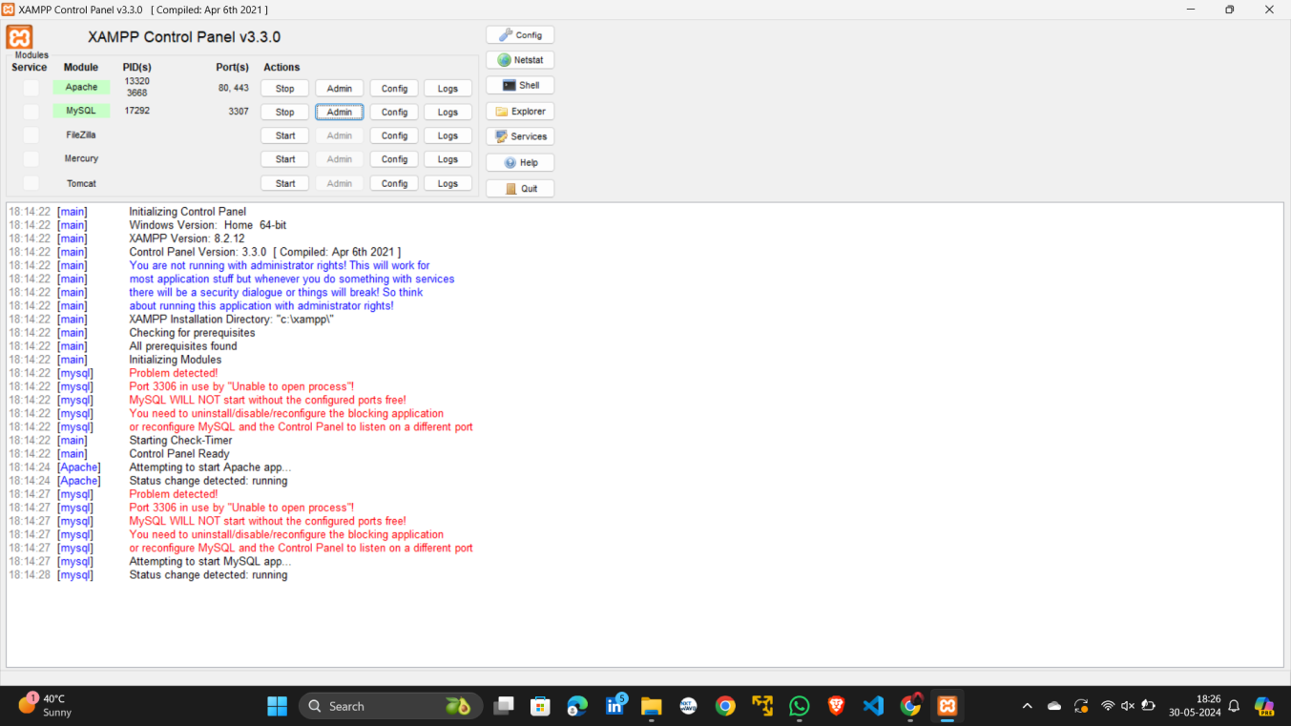

Figure 1 Start Apache and MySQL services using the XAMPP control panel.

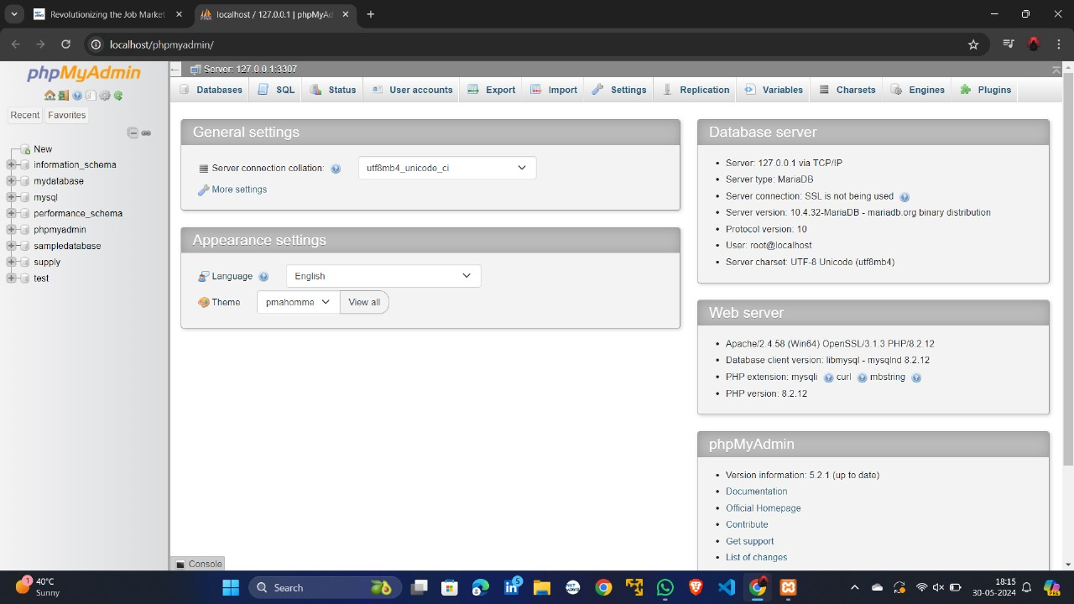

Figure 2 local host phpmyadmin live server which runs on our local machine

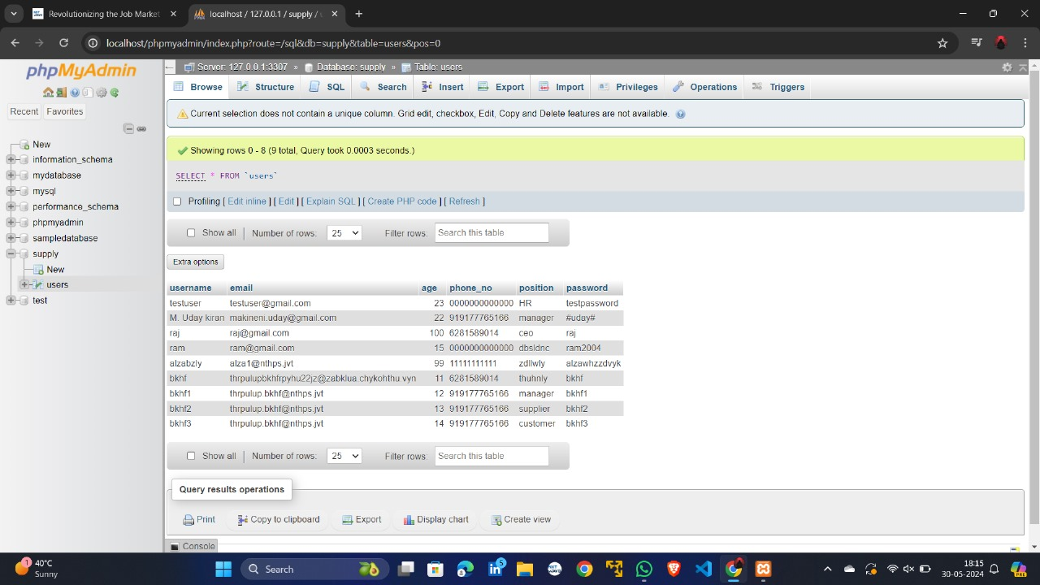

Figure 3 Our Live server 127.0.0.0:3307 with table name "users" which is located in supply folder

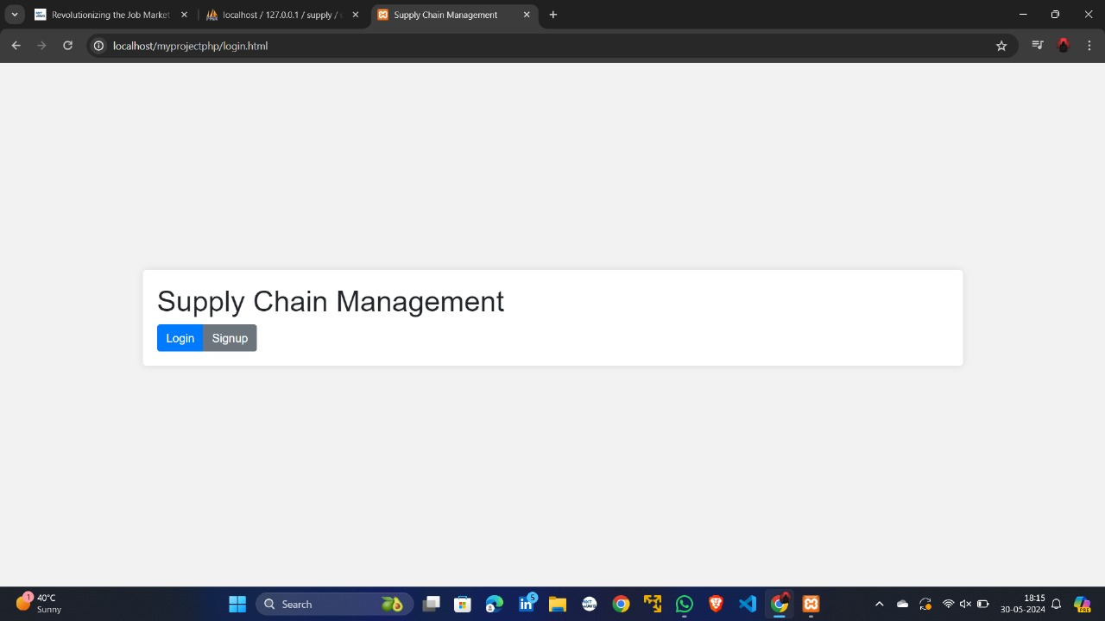

Figure 4 This is the landing page for our supply chain management system project

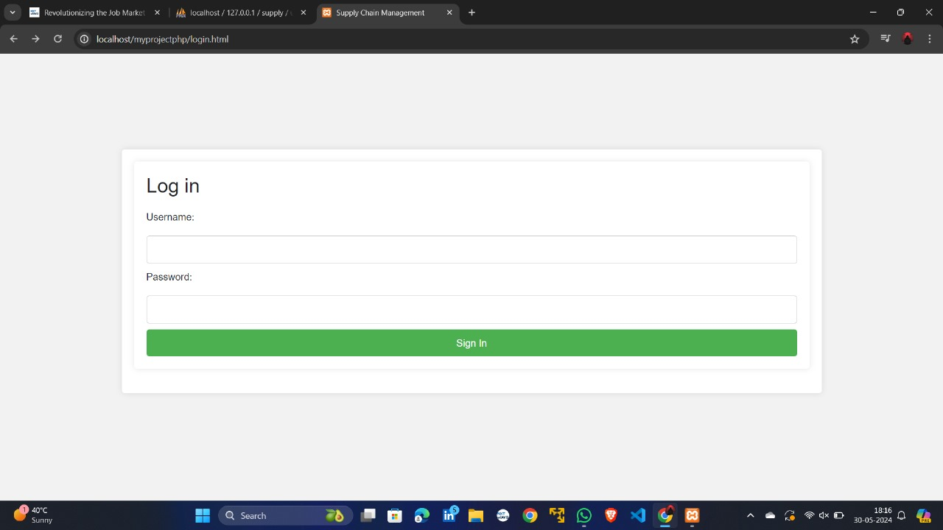

Figure 5 Login form

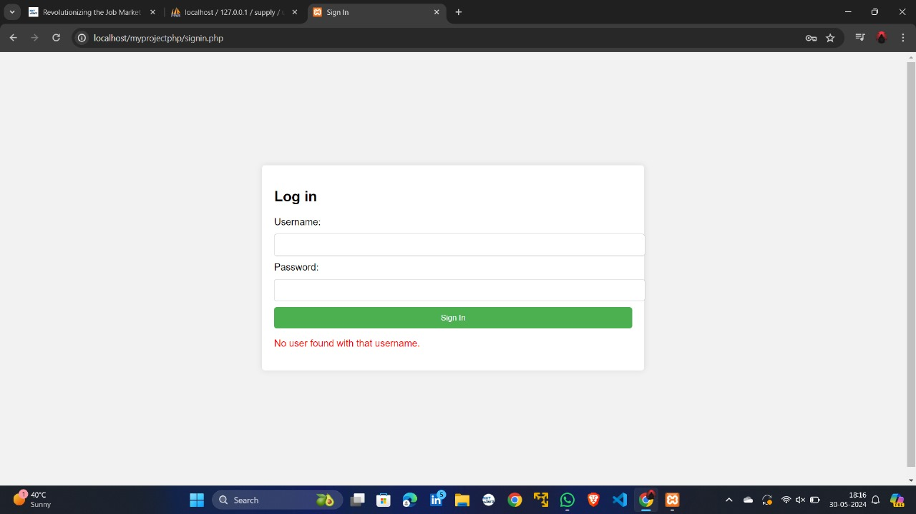

Figure 6 Error generated when an invalid user tries to login

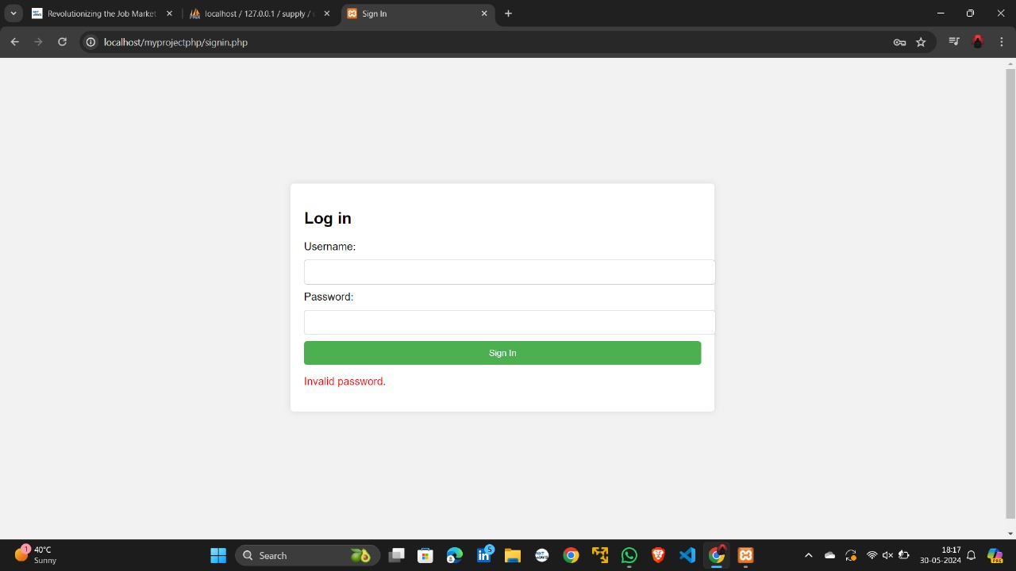

Figure 7 Error generated when an invalid password is tried to login

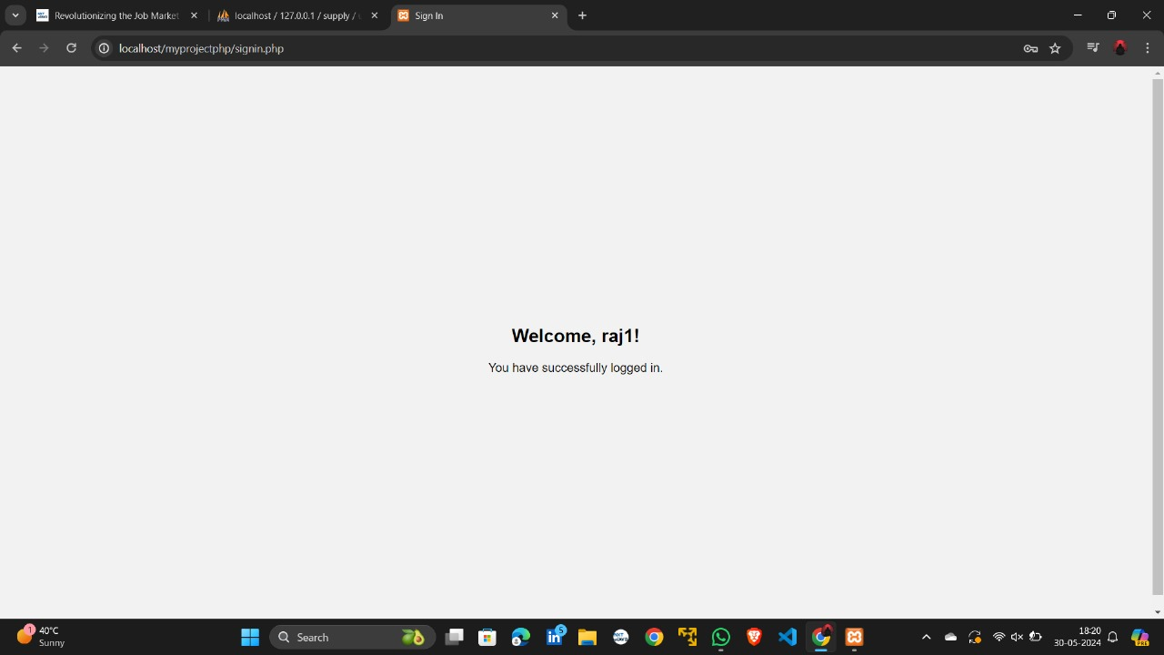

Figure 8 Welcome page after successful login

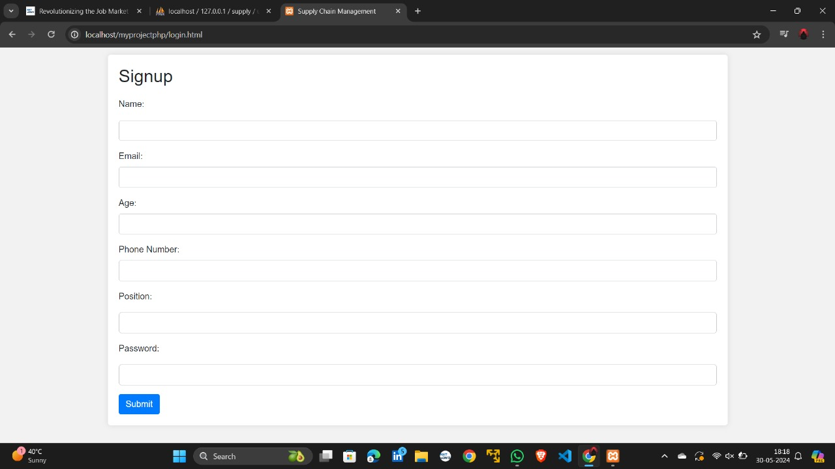

Figure 9 signup form

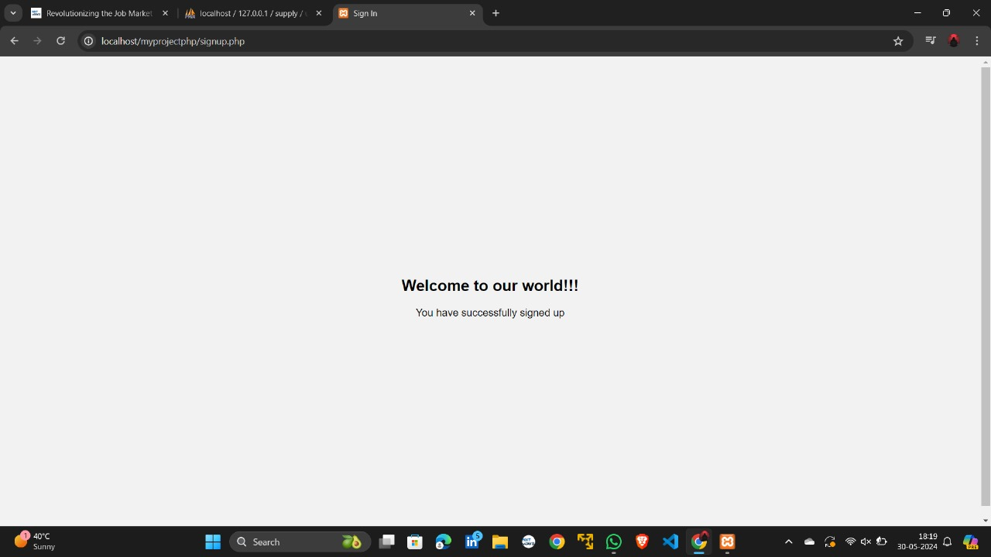

Figure 10 Welcome page after successful signing up

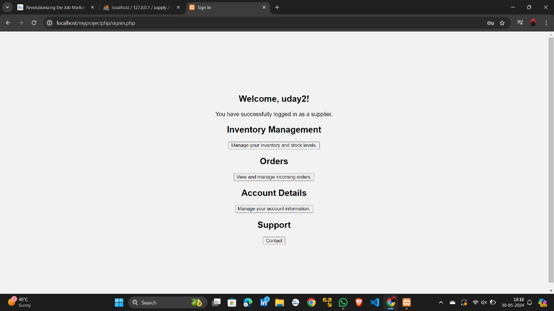

Figure 11 Home page of Supplier

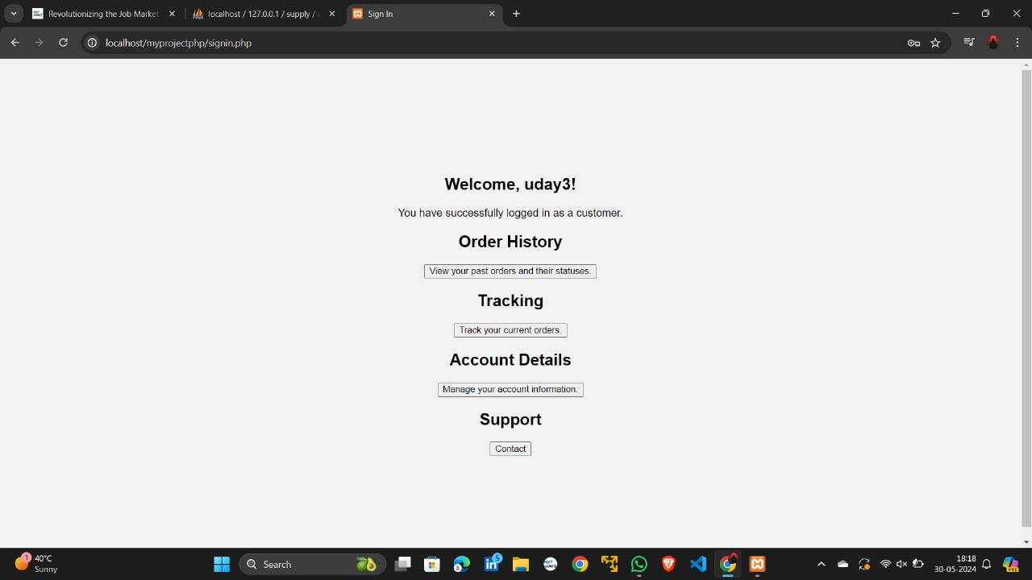

Figure 12 Home page of Customer

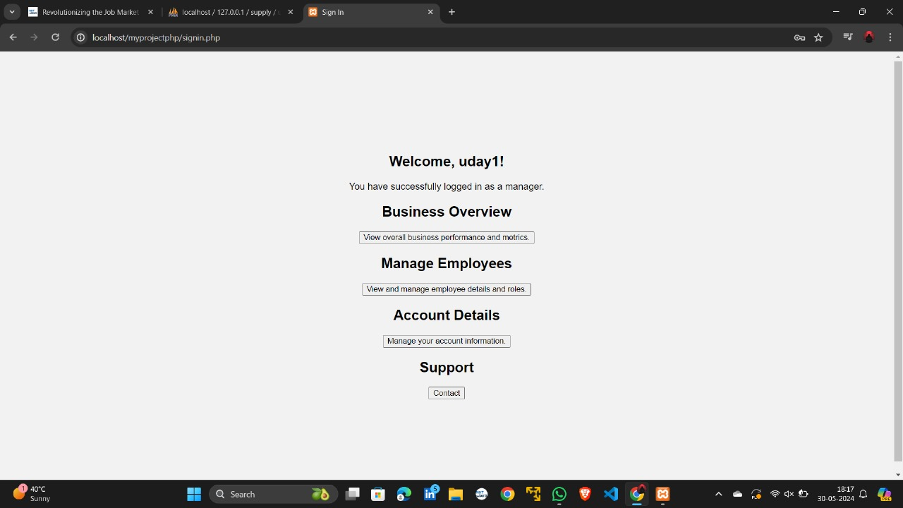

Figure 13 Home page of Manager

**Different Output Analysis**

**Registration Success**

* Users are able to register successfully with encrypted data and passwords stored in the database.
* Upon successful registration, users are redirected to a success page.

**Login Success**

* Users are able to login with their credentials, with passwords being decrypted for authentication.
* Upon successful login, users are redirected to their respective dashboards based on their position.

**Role-Based Dashboard Display**

* Different users see different dashboards: managers can manage the supply chain system, employees can view and update tasks, and suppliers can manage supplies and orders.

**Results**

* The system successfully encrypts and decrypts user passwords and data.
* Users are authenticated correctly based on their decrypted passwords.
* Different dashboards are displayed according to the user's role.

**Challenges**

* Ensuring secure storage and retrieval of user passwords with encryption .
* Handling different user roles and directing them to the correct dashboard.
* Setting up and configuring XAMPP for local server hosting.

**Conclusion**

The project successfully demonstrates a secure user authentication system for a supply chain management application. It highlights the importance of data encryption and decryption for protecting sensitive information and provides a role-based user experience tailored to the specific needs of different users in the supply chain.

**Future Work**

* Implementing additional security measures such as HTTPS and two-factor authentication.
* Enhancing the user interface for a better user experience.
* Adding more functionalities to the dashboards based on user feedback.
* Deploying the application on a live server for broader accessibility.